
INFO 3477 - DATABASE DRIVEN WEBSITES
PHASE I
Fall 2017

WEBSITE DEVELOPMENT TEAM: Cornel Amler, Grace Ransler, Grace Brockwell DATE: 9/30/17

PROJECT NAME: www.locorojo.com

PROJECT NARRATIVE:
Loco Rojo is a small, family run winery located in Northern California that is just starting out. This site is meant to be an informational landing page for people interested in their products, which are releasing in the near future (pending FDA approval). The website will function as a way to serve information about the family business with intentions to grow the business when appropriate. In order to properly inform the general audience, we will include a product page with a list of items that will become available. These products will be grouped by type, year and attributes (these elements will also be searchable). Because of the data-driven website, the limited products available now can be expanded upon in the future.
This website will also serve to connect possible suppliers and vendors to Loco Rojo, along with other laborers. Currently, the vineyard is produced by local neighbors helping during harvesting, but may expand to other laborers. The vineyard also shares the machinery with other local businesses, but also has plans to purchase their own machinery when able. This website can serve as a point-of-contact for any potential business relations beyond the local community.

PROJECT DEFINITION:
- Target Audience – Wine-lovers (potential customers), potential suppliers and vendors, and potential employees
- Objectives – Increase the reach of the brand of Loco Rojo in order to launch as effectively as possible once FDA approval of products occurs.

PROJECT NAVIGATION SCHEMA (A site navigation schema, in Visio, showing how pages and objects will be link). Here is a sample:

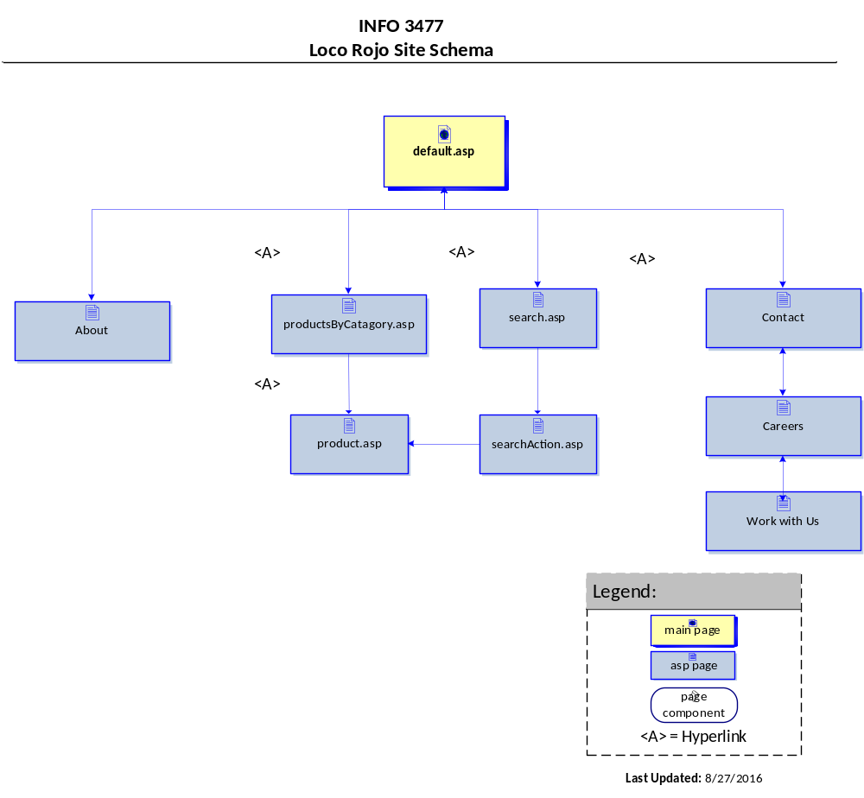

INDEX PAGE WIREFRAME (A screen blueprint providing a visual gui
de that represents the skeletal framework of the website):
